training 1 epoch...

1860.8577518463135 seconds used......

1 training finished! average train loss: 0.2868174946888324

evaluating...

Confusion matrix, without normalization

[[ 130 166 194]

[ 45 2475 177]

[ 5 151 5254]]

Normalized confusion matrix

[[2.65306122e-01 3.38775510e-01 3.95918367e-01]

[1.66852058e-02 9.17686318e-01 6.56284761e-02]

[9.24214418e-04 2.79112754e-02 9.71164510e-01]]

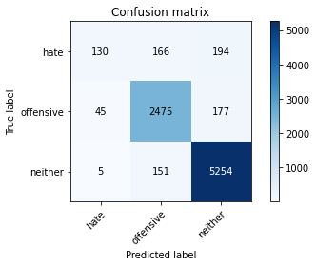

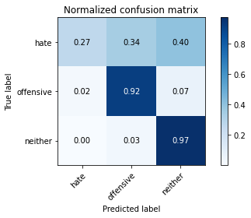

precision recall f1-score support

hate 0.72 0.27 0.39 490

offensive 0.89 0.92 0.90 2697

neither 0.93 0.97 0.95 5410

accuracy 0.91 8597

macro avg 0.85 0.72 0.75 8597

weighted avg 0.91 0.91 0.90 8597

average eval_loss: 0.269003729136704, accuracy: 0.9141561009654531

training 2 epoch...

1860.5984020233154 seconds used......

2 training finished! average train loss: 0.23059270235266527

evaluating...

Confusion matrix, without normalization

[[ 130 199 161]

[ 48 2549 100]

[ 17 196 5197]]

Normalized confusion matrix

[[0.26530612 0.40612245 0.32857143]

[0.01779755 0.94512421 0.03707824]

[0.00314233 0.03622921 0.96062847]]

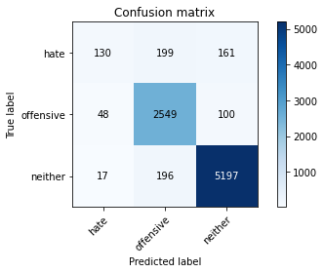

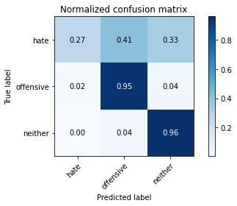

precision recall f1-score support

hate 0.67 0.27 0.38 490

offensive 0.87 0.95 0.90 2697

neither 0.95 0.96 0.96 5410

accuracy 0.92 8597

macro avg 0.83 0.72 0.75 8597

weighted avg 0.91 0.92 0.91 8597

average eval_loss: 0.2690566034857617, accuracy: 0.9161335349540537

training 3 epoch...

1859.0198011398315 seconds used......

3 training finished! average train loss: 0.17382856699042012

evaluating...

Confusion matrix, without normalization

[[ 145 188 157]

[ 56 2519 122]

[ 63 191 5156]]

Normalized confusion matrix

[[0.29591837 0.38367347 0.32040816]

[0.02076381 0.93400074 0.04523545]

[0.0116451 0.03530499 0.95304991]]

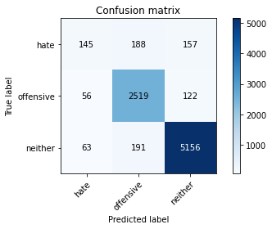

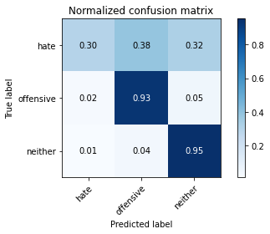

precision recall f1-score support

hate 0.55 0.30 0.38 490

offensive 0.87 0.93 0.90 2697

neither 0.95 0.95 0.95 5410

accuracy 0.91 8597

macro avg 0.79 0.73 0.75 8597

weighted avg 0.90 0.91 0.90 8597

average eval_loss: 0.3094487250089472, accuracy: 0.9096196347563104

training 4 epoch...

1859.7960584163666 seconds used......

4 training finished! average train loss: 0.11908084897717933

evaluating...

Confusion matrix, without normalization

[[ 161 175 154]

[ 84 2473 140]

[ 72 176 5162]]

Normalized confusion matrix

[[0.32857143 0.35714286 0.31428571]

[0.03114572 0.91694475 0.05190953]

[0.01330869 0.03253235 0.95415896]]

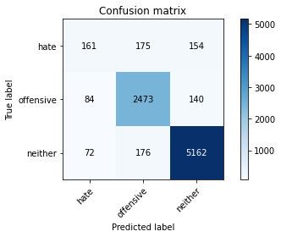

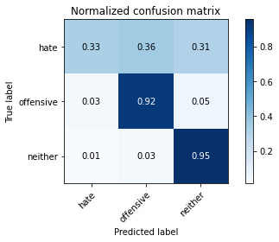

precision recall f1-score support

hate 0.51 0.33 0.40 490

offensive 0.88 0.92 0.90 2697

neither 0.95 0.95 0.95 5410

accuracy 0.91 8597

macro avg 0.78 0.73 0.75 8597

weighted avg 0.90 0.91 0.90 8597

average eval_loss: 0.42251076342288924, accuracy: 0.9068279632429918

training 5 epoch...

1859.6621804237366 seconds used......

5 training finished! average train loss: 0.08765494737092161

evaluating...

Confusion matrix, without normalization

[[ 191 145 154]

[ 167 2395 135]

[ 66 177 5167]]

Normalized confusion matrix

[[0.38979592 0.29591837 0.31428571]

[0.06192065 0.88802373 0.05005562]

[0.01219963 0.03271719 0.95508318]]

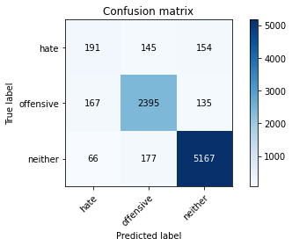

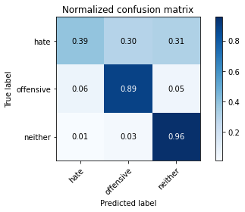

precision recall f1-score support

hate 0.45 0.39 0.42 490

offensive 0.88 0.89 0.88 2697

neither 0.95 0.96 0.95 5410

accuracy 0.90 8597

macro avg 0.76 0.74 0.75 8597

weighted avg 0.90 0.90 0.90 8597

average eval_loss: 0.4757036439168841, accuracy: 0.9018262184482959

model of 5 epoch

Confusion matrix, without normalization

[[ 214 154 164]

[ 136 2452 122]

[ 82 202 5071]]

Normalized confusion matrix

[[0.40225564 0.28947368 0.30827068]

[0.0501845 0.90479705 0.04501845]

[0.01531279 0.03772176 0.94696545]]

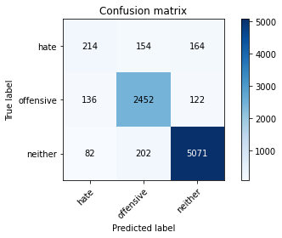

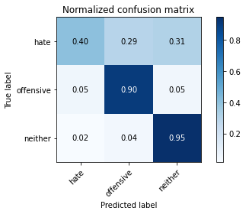

precision recall f1-score support

hate 0.50 0.40 0.44 532

offensive 0.87 0.90 0.89 2710

neither 0.95 0.95 0.95 5355

accuracy 0.90 8597

macro avg 0.77 0.75 0.76 8597

weighted avg 0.90 0.90 0.90 8597

average eval_loss: 0.5143313533491131, accuracy: 0.8999651041060835